ASMCF–SSFH
Postgraduate Study Day 2021
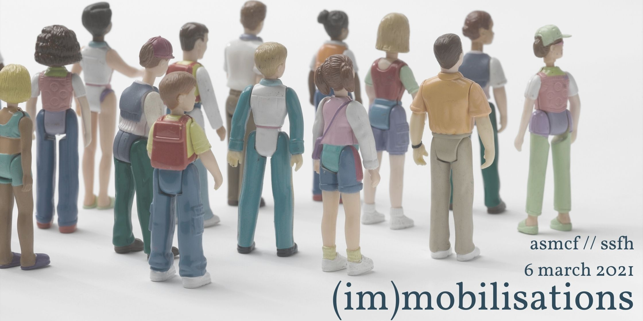

Call for papers – (im)mobilisations
A virtual study day to be held on 6 March 2021
Keynote: To Be Confirmed
« L'histoire sociale enseigne qu'il n'y a pas de politique sociale sans un mouvement social capable de l'imposer… En conséquence, la question…est de savoir comment mobiliser les forces capables de parvenir à cette fin et à quelles instances demander ce travail de mobilisation. »
Pierre Bourdieu, Contre-feux 2 (2001)
In the past twelve months, we have seen people across the globe seek to mobilise around many different issues, whilst simultaneously being immobilised. This tension, between the desire for mobility and mobilisation, and the limitation or prevention of such movement(s), has been endemic across history.
This Study Day will digitally unite postgraduates to examine how and why people mobilise, (or are prevented from doing so) or are moved, focusing on the period 1789 to the present. We invite proposals for ​20-minute papers in English or French​​ from across French and Francophone history and society, literature, politics, linguistics, film and visual cultures, philosophy, critical theory, and other disciplines, as well as interdisciplinary approaches. We particularly welcome contributions from postgraduates overseas and those from under-represented groups.

Suggested topics include, but are not limited to contemporary or historical studies on:
- Museums and archives
- Memory/le devoir de mémoire
- Disability, pain and illness
- Exile(s), migration and refugees
- Institutions, spaces and places
- Buildings, objects and sites
- Gender and Sexuality
- Footnotes to history
- Power and revolution
- Warfare and soldiers
- Resistance
- Emotions and their manipulation
- La Francophonie/beyond the Hexagone
- (Post)colonialism and (de)colonialism
- Race and racism
- Grassroot activism/Elite policy
- Imagined communities
- Class and capital; social mobility
- Environmental issues
- National Politics, International Influences and Transnationalism
- Borders and Blockades
- (Digital) Activism and Slacktivism
- Performative power and symbolic violence
- Civic freedoms and pandemics
- Occupation
- Incarceration and Prisons
- Flânerie
- Press, propaganda or political images

Abstracts of no more than 250 words, in either English or in French, should be sent to asmcf.ssfh.studyday@gmail.com. ​Submissions should be received by 9:00 AM (GMT) on Monday 25 January 2021.
Call for Flash Presentations
Share your voice! We welcome proposals from MA and early PhD students ​​to explain their own research in three minutes, limited to one PowerPoint slide OR one creative method of their choice. Presentations on any topic connected to French and Francophone studies and histories are welcome.
Please email asmcf.ssfh.studyday@gmail.com to express your interest.

The Study Day will include professional development panels and an opportunity to engage with senior academics from other institutions. It is generously funded by the Association for the Study of Modern and Contemporary France ​(​ASMCF​) and the Society for the Study of French History ​(SSFH)​​. Attendance is free but all attendees are kindly requested to become members of one of the two societies on or before the day via the societies’ websites. We will endeavour to ensure that the virtual conference is fully accessible, and we are very happy to discuss particular needs that participants might have and how we can best accommodate these.
Organising Committee​: Daniel Baker (Cardiff, SSFH), Pallavi Joshi (Warwick, ASMCF) and Helen McKelvey (QUB, ASMCF)
asmcf.org @asmcf frenchhistorysociety.co.uk @FrenchHistoryUK

